**Operating System(RCS-401)**

**Date:** 25th April 2020

**Unit: Concurrent Processes (CO2)**

**ASSIGNMENT NO 2**

|  |  |
| --- | --- |
| **Course Outcomes** | |
| C216.1 | Understand the structure and functions of OS |
| C216.2 | Learn about Processes, Threads and Scheduling algorithms |
| C216.3 | Understand the principles of concurrency and Deadlocks |
| C216.4 | Learn various memory management scheme |
| C216.5 | Study I/O management and File systems. |

**Q).** Show how Lamport’s “Bakery Algorithm” meets all the three requirements of a satisfactory Critical Section Solution.

**Q).** Write a solution for “Sleeping Barber” Problem, using Monitor.

**Q).** Show how SEMPHORES can be used to achieve the precedence of the following graph? Answer the following questions:-(a)At least how many Semaphores will be required? GiveJustification for your answer.(b)What will be the initial Count of each semaphore?(c)What will be the advantage of using “Counting Semaphores”rather than “Binary Semaphores”?(d)Can “Condition” variables be used to provide the same solution?

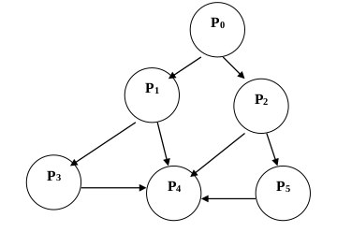

**Q).** Is it possible to have a solution for Dijkstra’s “Dining Philosophers” Problem,that ensures, under all possible conditions:-(a)That no philosopher ever faces condition of “Starvation”AND(b)The solution meets the requirement of “Progress”